1. Overview

Inventory Management is a collection of spreadsheets used to collect and report on the inventory at both the warehouse and various storage locations throughout the state. It will be required that users of the system have access to the Win 16 icon in “Virtual Workplace” from the workstation that you use.

1. Starting the application
   1. You must first sign into American Red Cross – Virtual Workplace which is accessed via a browser (preferably chrome) at the URL https://**workplace**.**redcross**.org
   2. Once you are signed into virtual workplace you will then be presented with the following screen.

Figure 1

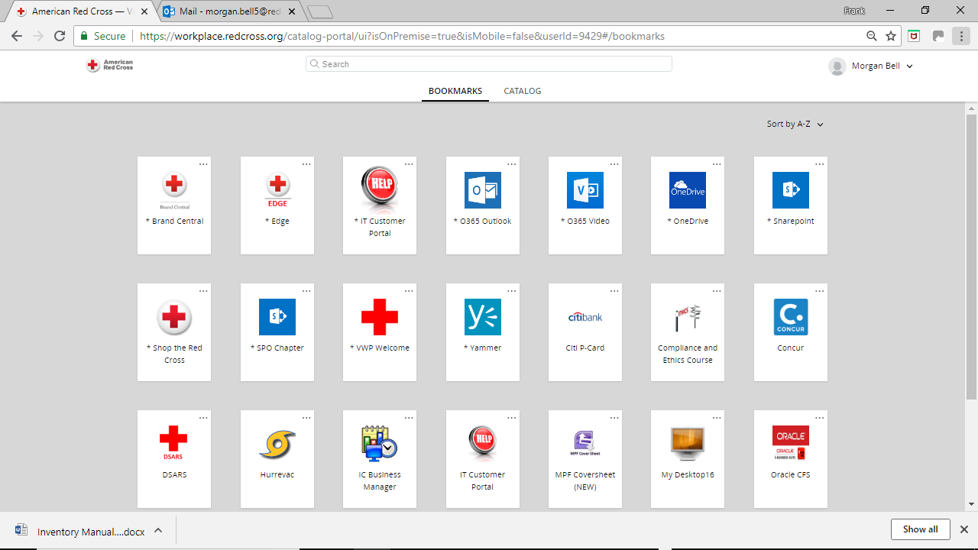

You will then select the icon “My Desktop 16”. Once selected you will then be logged into a virtual windows session shown below.

Figure 2

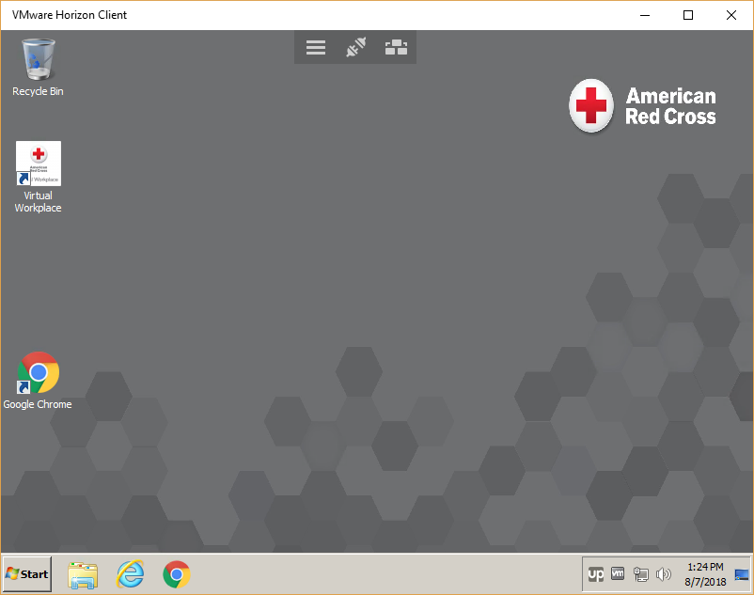

Once you are at this screen, you will then click on the icon titled “Virtual Workplace”. You will be presented a screen just like Figure 1. The reason you are running “Virtual Workplace” again is so that the same version of Excel will be run by all users of these spreadsheets to facilitate consistent support and troubleshooting. Once “Virtual Workplace” is loaded, you will then click the “OneDrive” icon shown in the figure 3.

Figure 3

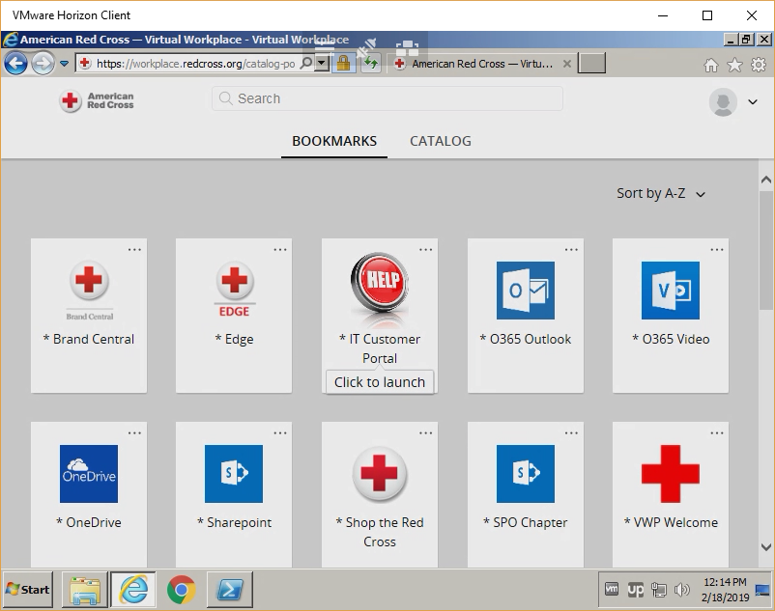

You will then be asked to sign in again as shown below in figure 4 below

Figure 4

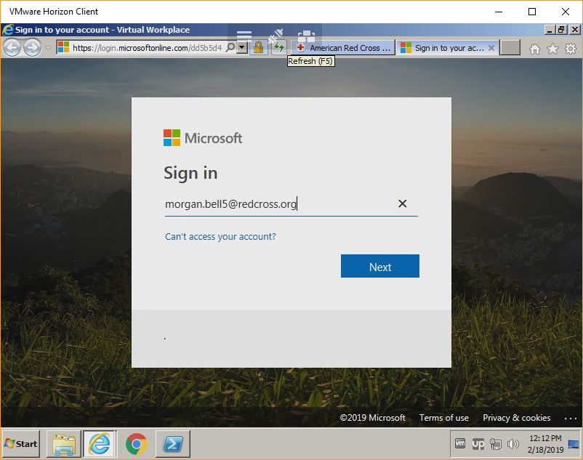

1. One Drive
   1. Overview

One drive provides a platform to share files between people. Users can be given read or edit rights to the files that are shared. This is where the excel spreadsheets are stored. Your role at Red Cross will determine what rights you will have to the spreadsheets. You will be given edit access to the spreadsheet assigned to your locations. Depending you your role you may be presented a screen like below.

Figure 5

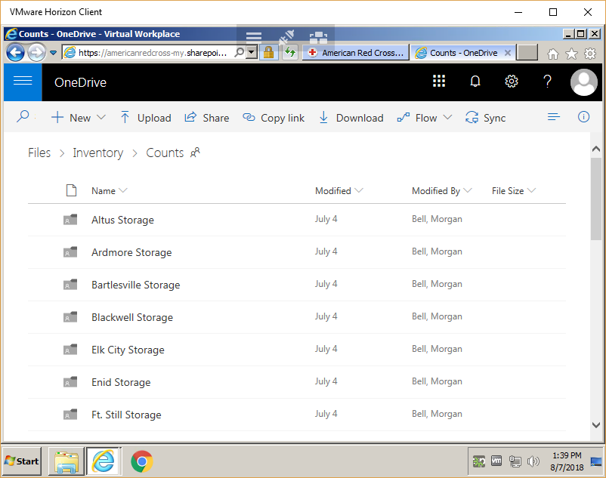

Click on the folder that represents your storage location. You will then see a file titled “Inventory Count – XXX” where XXX will represent the name of your location. Click on that file to open the spreadsheet. You may only be presented with the spreadsheet instead of the folder. The spreadsheet is in the format described below.

1. InventoryCount-XXX .xlsm 🡨 XXX represents the storage location
   1. Overview

InventoryCount-XXX is a spreadsheet designed to capture the number of items at the location for any given month. This spreadsheet will be rolled up into a consolidated spreadsheet showing the total amounts in Oklahoma for each item and will provide a report for each location of its inventory counts. Open the spreadsheet, click on the file name.

* 1. Navigation

Once the spreadsheet has been loaded into excel you will be presented a screen like the one shown below.

Figure 6

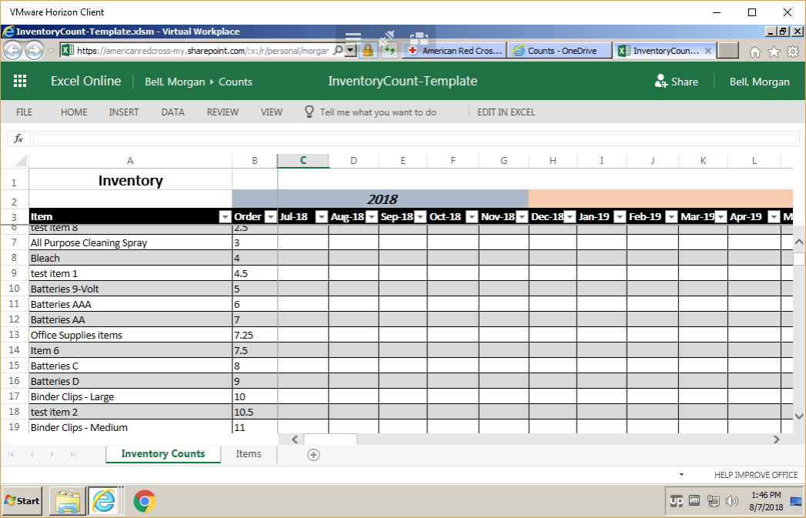

At the top of the spreadsheet you will notice the caption “EDIT IN EXCEL”. You will click on that caption to make the spreadsheet capable of entering information.

Figure 7

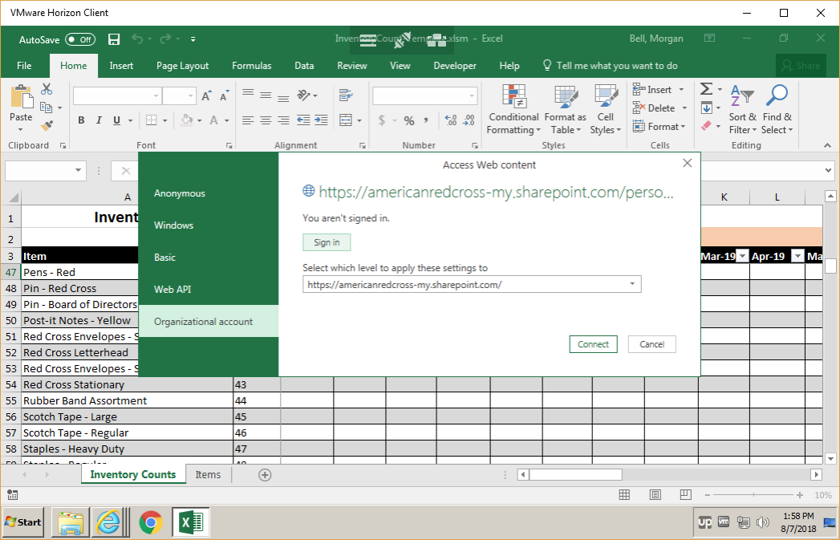

When entering into edit mode you will be prompted to sign into access the spreadsheet. Select “Organizational account” and then click on “Sign in”. You will then be asked to input your Red Cross email account. You will then be taken back to the screen shown in figure 6 and at that point you can select “Connect” which will then load the spreadsheet in edit mode.

The spreadsheet has several columns. The first column contains the list of inventory items. There may be items that you do not currently store, so will not have to provide counts for those items. The “order” column is an internally used column to facilitate updating new items to this spreadsheet. The other columns are each of the months of the years 2019 and 2020. Depending on the month you will be tasked with providing the total amounts you have for each item in your location. So, for instance, if you are collecting counts for the month of Jul-19 you for AAA batteries, you will input the number of packages in the cell at the intersection of Jul-19 and “Batteries AAA” as shown in figure 8.

Figure 8

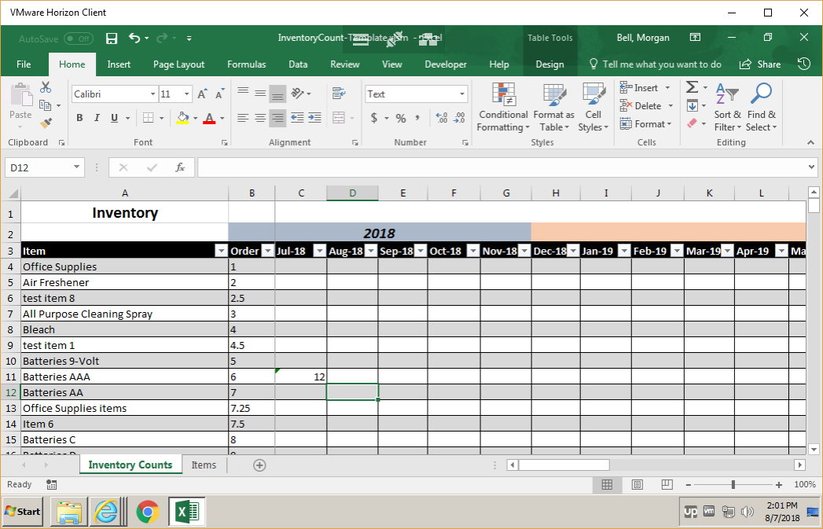

You will continue to do that for each of the items that you store for that month. After completing that task you then click on the “X” in the top right hand corner of the excel spreadsheet. The “X’ is shown in red below in figure 8. You will then be asked if you want to Save, Don’t Save or Cancel as shown in figure 9. Select “Save”. After selecting “Save” you will then be presented with the following screen in figure 10.

Figure 9

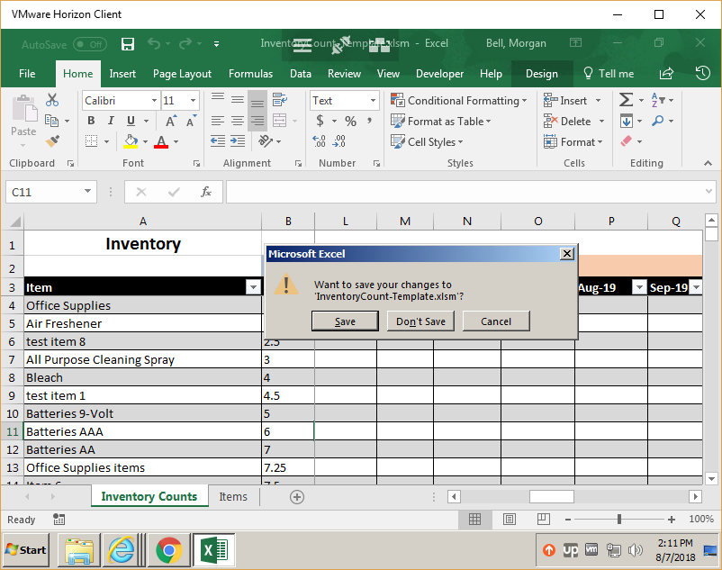

Figure 10

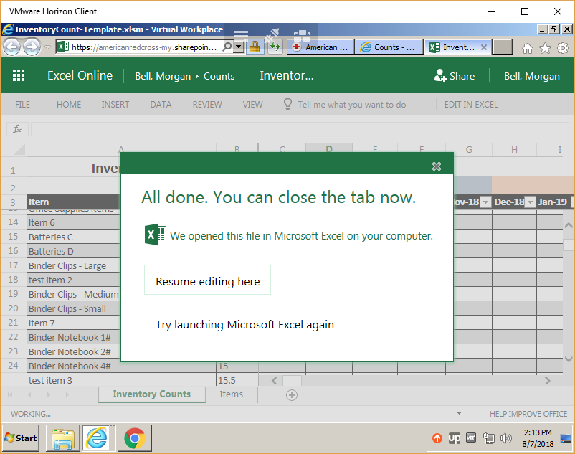

At that point you can then click the “x” on the excel tab with the title of your spreadsheet located at the top of internet explorer. You have then completed editing the counts for your location for the month requested.

If you are finished, you can then select the “Start” command at the bottom left hand corner of your session and the select “Log Off” as shown in figure 11.

Figure 11

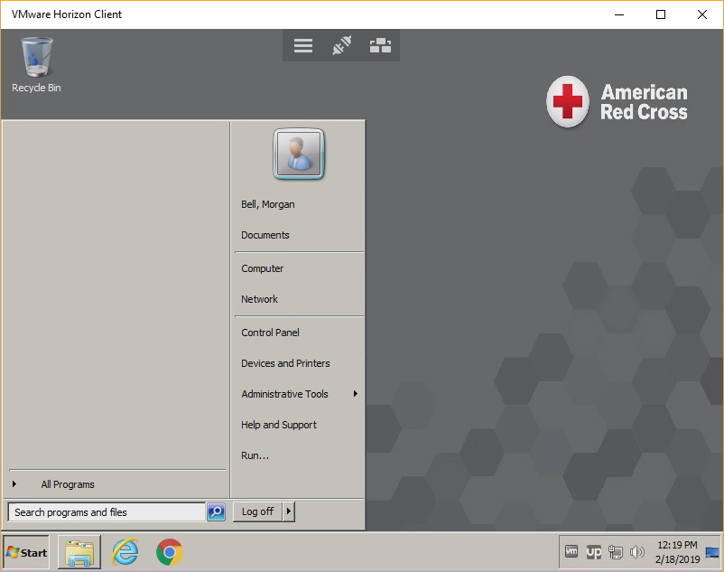

That completes the inventory count for your location.

1. For those of you that are required to look at total system inventory you should be able to see the spreadsheet in one drive titled “InventoryCountSummary.xlsm”. Click on that filename and you will then be presented with the following screen.

Figure 12

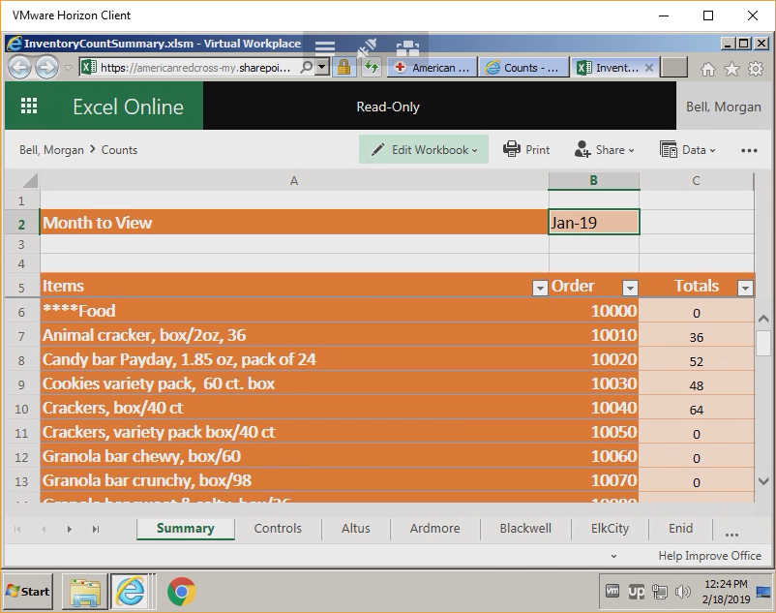

Select the “Edit Workbook” and then select “Open in Excel”.

In figure 13 you are presented with a summary screen that contains the list of inventory a totals column and a column for every location.

Figure 13

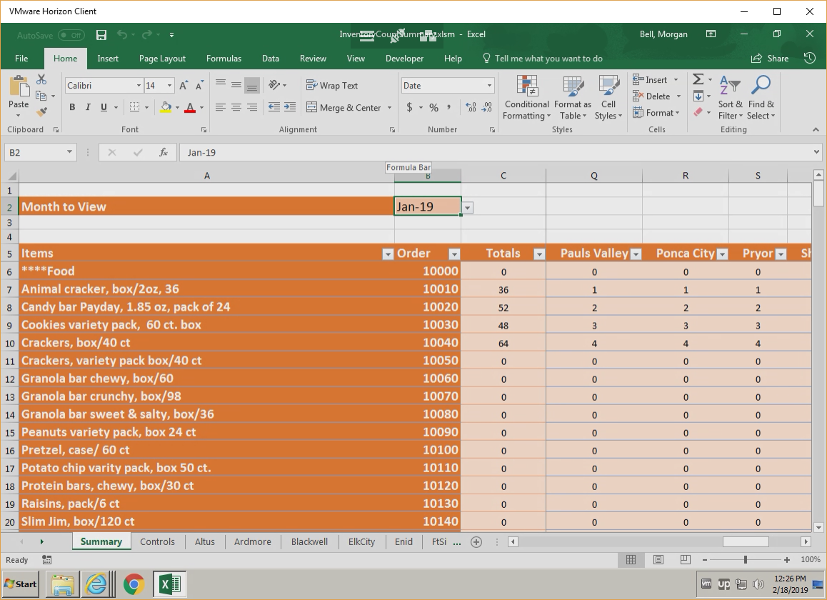

In column “B2” you will see a drop down list with a date. You can select which month for the totals you want to view. In figure 13 the month is Jan-19. The summary contains a read-only view of each of the locations and you can navigate to the location using the tabs at the bottom of the spreadsheet. For instance, if you select the “Altus” tab you will be presented with the view shown in figure 14.

Figure 14

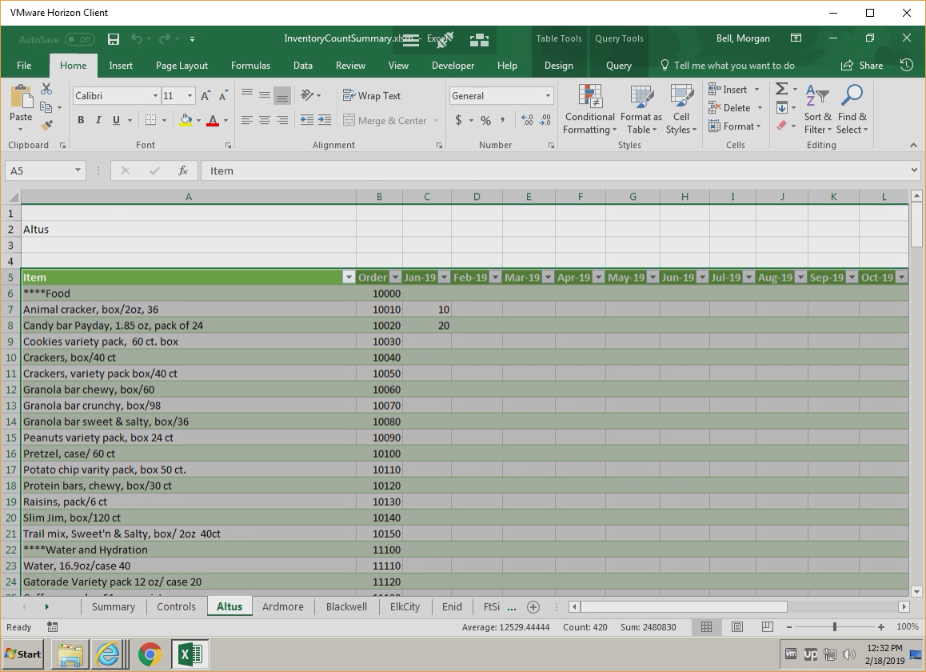

This allows you to view each of the location’s data for each month, whereas the summary only allows you to view the data for each location for a given month.

Prior to viewing the summary data for a given month you need to load the data from each of the locations. First go to the “Summary” tab at the bottom of the spreadsheet. Next, select the option “Data” then select the sub-option “Refresh All”. This will then go out to each of the locations and grab the data that is saved in each of those spreadsheets to provide an updated summary of the inventory system wide as shown in figure 15.

Figure 15

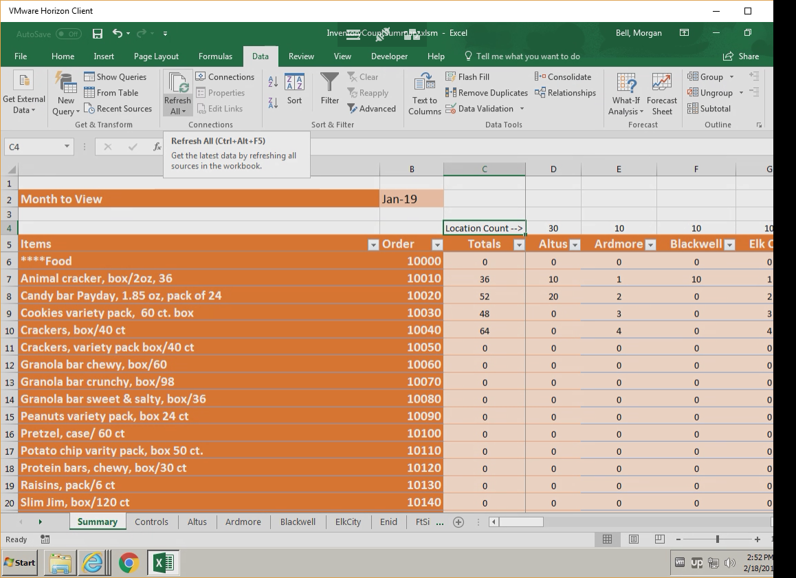

The row immediately above the location headings contains a total count of all items in each location. Those locations that have not yet entered their counts will show a value of 0. Once the location has entered the data and notified you, you can then refresh the data to get the updated totals. To save the data, just click on the X at the top right hand corner of the spreadsheet and select save. You can then log out of the system as described in page 10.

Help

If you have any issues you can contact Morgan Bell at 918-619-2894. Issues should be able to be resolved via Skype.